**Ideation Phase**

**Empathize & Discover**

|  |  |
| --- | --- |
| Date | 19 September 2023 |
| Team ID | NM2023TMID08200 |
| Project Name | iRevolution: A Data-driven Exploration of Apple's iPhone Impact in India |
| Maximum Marks | 4 Marks |

**Empathy Map Canvas:**

User's feelings towards iPhones and their impact in India User's thoughts and concerns about the affordability of iPhones in India User's experiences and challenges in accessing and using iPhone apps and services User's perception of Apple's marketing strategies and their influence on iPhone adoption in India.

User's perceptions and experiences of the impact of iPhone usage on digital literacy and access to information in rural areas of India User's opinions and experiences regarding the impact of iPhone manufacturing and assembly units on local employment and the economy in India

**Example:**

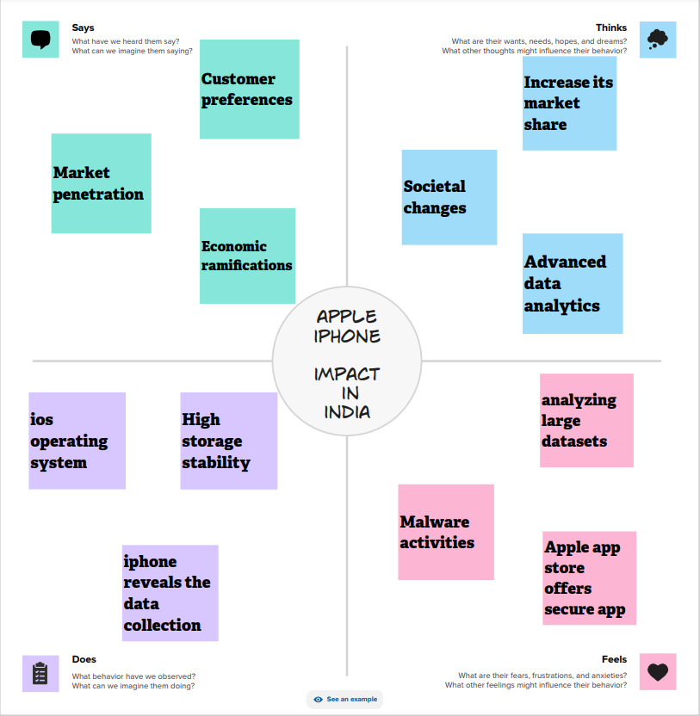

Reference: <https://www.mural.co/templates/empathy-map-canvas>